Deep Learning Final Project
Paper Implementation & Experimental Reproduction
DL - Mans 46

1. Project overview
In this final project, you will work in teams of three to implement a published deep learning paper in PyTorch, reproduce key results using the same dataset as the paper, run controlled experiments (ablations), and present a clear analysis of your results (including failure cases).
This project evaluates implementation correctness, experimental rigor, and clear communication. It is not a leaderboard competition.

2. Paper selection rules
- Team size: 3 students per group.
- Paper choice: Each team chooses ONE paper from the approved list. No overlap between teams.
- Dataset: You must use the same dataset used in the original paper (or an officially stated subset/variant).
- Assignment: Paper assignments are approved on a first-come basis.

3. Compute and scope policy
- Compute limit: Must be feasible on a single free Colab/Kaggle GPU (e.g., T4/P100).
- Runtime target: A full training run should complete in <= 6 hours.
If the original paper requires heavy computation, you must submit a Scope Adjustment Proposal during Week 1. The instructor will decide whether the reduced scope is acceptable.

3.1 Scope Adjustment Proposal (Week 1 - required if needed)
- What you will reduce (dataset size, epochs, model width/depth, input resolution, etc.).
- Why this preserves the core idea of the paper.
- Estimated runtime and GPU/CPU memory requirements.
- Fallback plan if training is unstable or too slow.
No unapproved scope changes are allowed.

4. Implementation policy (strict)
You must implement the model and training pipeline yourself in PyTorch, including: model definition, training loop, loss computation, evaluation, and logging.
The following are strictly prohibited:
- Copying or forking a full open-source implementation of the paper.
- Using a public GitHub repository implementation as your starting point.
- Copy-pasting large blocks of architecture or training code from external repositories.
- Reusing external training scripts or notebooks that already implement the paper end-to-end.
You may consult external resources for understanding (e.g., reading blog explanations), but your code must be independently written. Similarity to public implementations may be checked.

5. Academic integrity
AI usage policy:
- The use of AI tools (e.g., ChatGPT, Copilot, or similar systems) is prohibited for this project, including writing code, debugging, writing the report, or preparing slides.
Violations will be treated as academic misconduct.

6. Experimental requirements

6.1 Reproduction
- Reproduce at least one key result from the paper (a main table row, or a key figure trend).
- Clearly report the metric, dataset split, and training setup used.
- Compare your result to the paper and explain gaps (if any).

6.2 Controlled ablations (minimum 3)
You must run at least 3 controlled ablation experiments. Each ablation must change only one variable, be reported in a table, and be interpreted (what changed and why).
Examples:
- Remove augmentation
- Change model depth/width
- Change optimizer or learning-rate schedule
- Remove a component (e.g., residual connection)
- Change input representation (e.g., MFCC vs log-mel)

7. Approved paper list (no overlap between teams)

Paper | Link
Beyond a Gaussian Denoiser: Residual Learning of Deep CNN for Image Denoising (DnCNN) | https://arxiv.org/abs/1608.03981
DCASE 2016 Acoustic Scene Classification Using Convolutional Neural Networks (technical report) | https://dcase.community/documents/challenge2016/technical_reports/DCASE2016_Valenti_1011.pdf
Emotion Recognition from Speech: A Comparative Analysis of Techniques and Datasets | https://arxiv.org/abs/1912.10458
DeepFM: A Factorization-Machine based Neural Network for CTR Prediction | https://arxiv.org/abs/1703.04247
ECG-Based Heartbeat Classification Using Deep Learning (Kachuee et al., 2018) | https://arxiv.org/abs/1805.00794
Entity Embeddings of Categorical Variables (Guo & Berkhahn, 2016) | https://arxiv.org/abs/1604.06737
ECG Heartbeat Classification: A Deep Learning Approach (Kachuee et al., 2018) | https://arxiv.org/abs/1805.00794
Deep Convolutional Neural Networks and Data Augmentation for Environmental Sound Classification (Salamon & Bello, 2016) | https://arxiv.org/abs/1608.04363
DeepSleepNet: A Model for Automatic Sleep Stage Scoring (Supratak et al., 2017) | https://arxiv.org/abs/1703.04046
Character-level Convolutional Networks for Text Classification (Zhang et al., 2015) | https://arxiv.org/abs/1509.01626
Traffic Sign Recognition with Multi-Scale Convolutional Networks (Sermanet & LeCun, 2011) | https://yann.lecun.com/exdb/publis/pdf/sermanet-ijcnn-11.pdf
Tversky loss function for image segmentation (Salehi et al., 2017) | https://arxiv.org/abs/1706.05721
Class-Balanced Loss Based on Effective Number of Samples (Cui et al., 2019) | https://arxiv.org/abs/1901.05555
Learning Imbalanced Datasets with Label-Distribution-Aware Margin Loss (LDAM) (Cao et al., 2019) | https://arxiv.org/abs/1906.07413
Asymmetric Loss For Multi-Label Classification (Ben-Baruch et al., 2020) | https://arxiv.org/abs/2009.14119

8. Deliverables

8.1 Code repository
You can use this template repo to build your code by clicking on “Use this template” and choosing “Create a new repository”. https://github.com/aielawady/dl_course_project_template
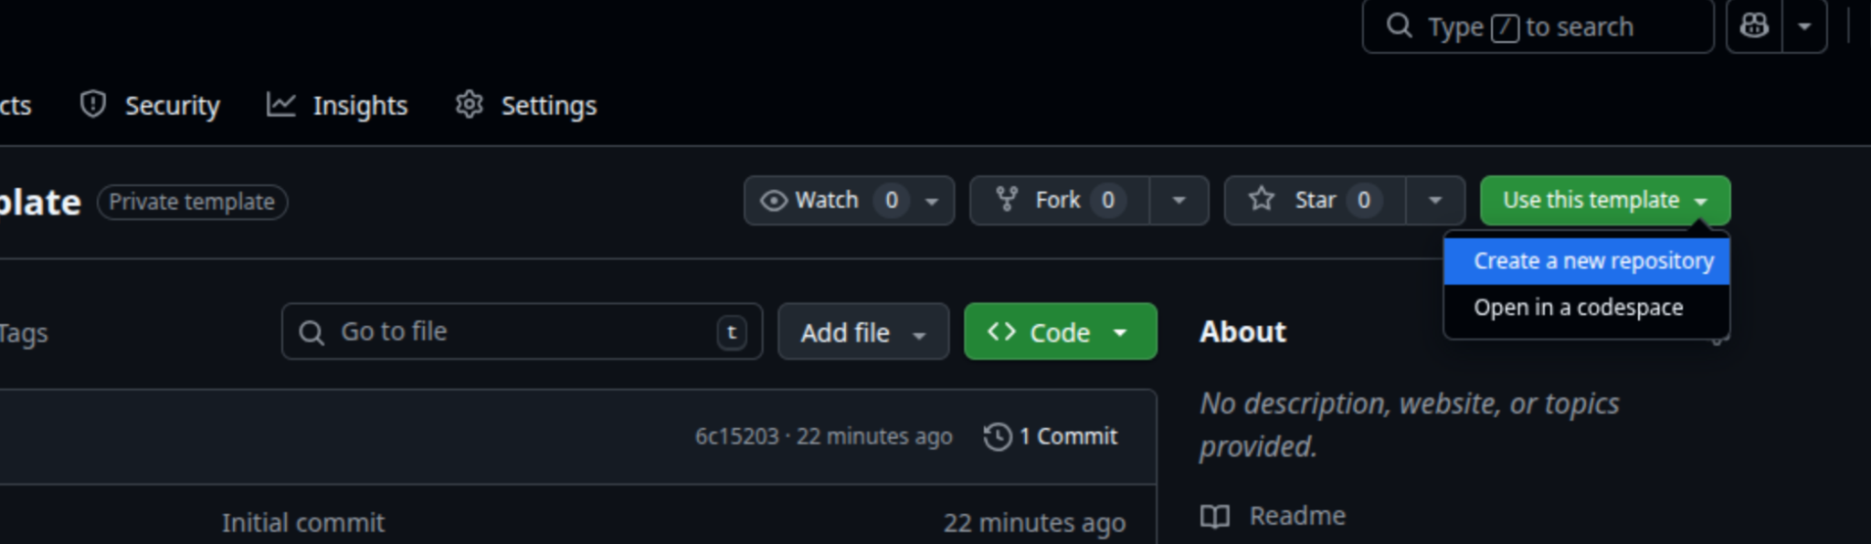

- A private Git repository.
- Repository must remain private until the course ends.
- README with environment setup, dataset download steps, training command, evaluation command, and expected outputs.
- At least one saved checkpoint for your best model, and logs that match your reported numbers. (on Google Drive)

8.2 Report
Length: 6-8 pages (excluding references and appendix).
Required sections:
- Abstract (3-5 sentences)
- Introduction and problem motivation
- Paper summary (key idea and contribution)
- Dataset and preprocessing
- Model and training details
- Experiments and ablations
- Results and error analysis
- Limitations
- References
Mandatory: contribution table in the report:
- Include a table describing each member's contribution (example below).
Team Member | Contributions
Student A | ...
Student B | ...
Student C | ...

8.3 Presentation
- 10 minutes presentation + 5 minutes Q&A.
- Must include: problem, method, main reproduction result, ablation table, failure cases, and key takeaways.
- Mandatory: include a contribution table slide.

9. Submission policy
Deliverables must be locked and submitted on Google Classroom one day before the presentation day.
You must submit:
- Private Git repository link (add me to the repo)
- Archive of the Git repo (zip file)
- Report PDF
- Slides PDF

10. Grading rubric (100 points)
Category | Points
Paper understanding and framing | 10
Correct dataset usage and no leakage | 10
Implementation correctness | 20
Experimental design and ablations | 20
Results and analysis (incl. failure cases) | 20
Reproducibility and code quality | 10
Report and presentation clarity | 10

11. Submission checklist
- Scope Adjustment Proposal submitted and approved (if needed)
- Training and evaluation run end-to-end from a clean environment
- At least one key result reproduced and reported
- At least 3 controlled ablations completed and summarized in a table
- Error analysis included (e.g., confusion matrix, representative failures)
- Contribution table included in both report and presentation
- Git repository is private
- All deliverables submitted on Google Classroom one day before presentation day
Good luck - prioritize clean baselines and controlled experiments over unnecessary complexity.

